AQMA Boundary Maps
Figure 1 - Cardiff City Centre AQMA
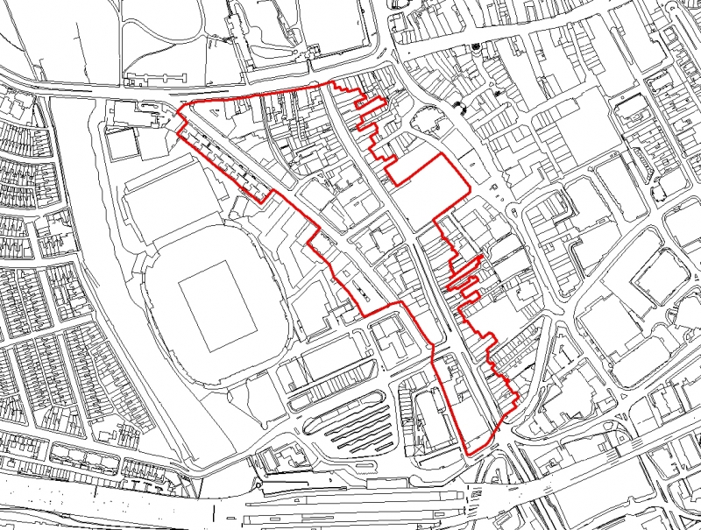

Figure 2 - Stephenson Court AQMA

Figure 3 - Ely Bridge AQMA
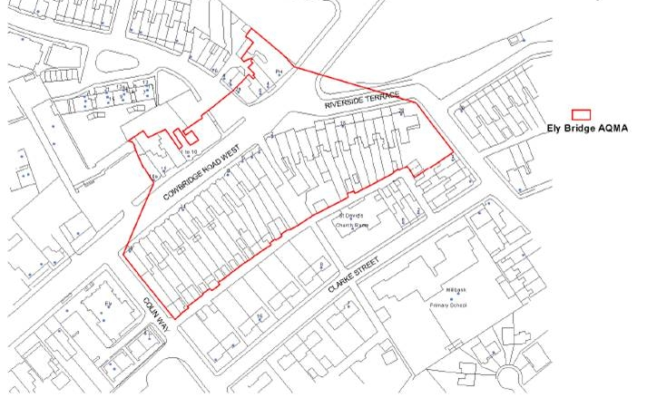

Figure 4 - Llandaff AQMA
