The City of Cardiff Council
‘Real’ Living Wage Accreditation Support Scheme 2022/2023
Application Form
Name of organisation:

Address:

Number of Employees:

Annual Turnover:

Please tick to confirm that your organisation became an accredited Living Wage organisation in 2022/23 and your Licence Agreement is attached to this application.

Please tick to confirm that your business occupies a non-domestic property within Cardiff Council’s area and your business is liable for the payment of Business Rates and is not in deficit.
Please tick if you comply with State Aid de minimis limits whereby a business must not have received state aid exceeding 200,000 euros (£230,000) in the last 3 years (current year plus preceding 2). State aid includes reliefs, grants, interest rate and tax relief, subsidies, guarantees, etc.
Name of Bank
Sort Code
Account Number

Name of Applicant:
Signature:
Date:
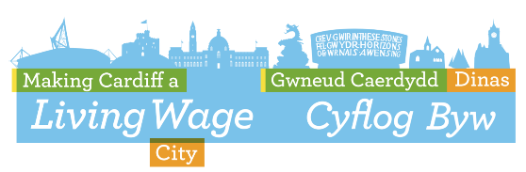
For the office use:
Date of accreditation
Amount of award | £
Date of award

